**Project Design Phase-II**

**Data Flow Diagram&User Stories**

|  |  |
| --- | --- |
| Date | 18 June 2025 |
| Team ID | LTVIP2025TMID45426 |
| Project Name | GrainPalette - A Deep Learning Odyssey In Rice Type Classification Through Transfer Learning |
| Maximum Marks | 4 Marks |

**Data Flow Diagrams:**

A Data Flow Diagram (DFD) is a traditional visual representation of the information flows within a system. A neat and clear DFD can depict the right amount of the system requirement graphically. It shows how data enters and leaves the system, what changes the information, and where data is stored.



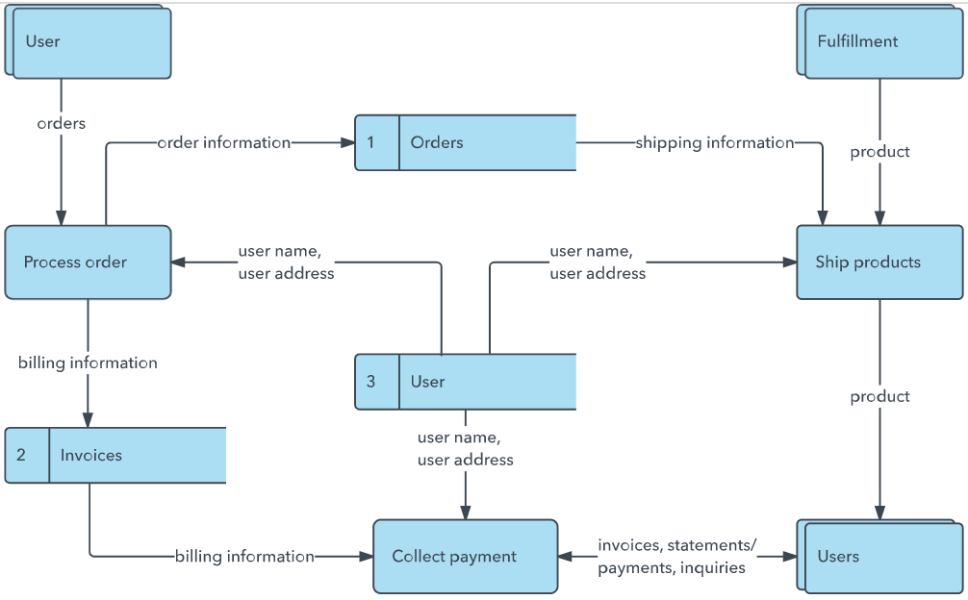**Example:** [**(Simplified)**](https://developer.ibm.com/patterns/visualize-unstructured-text/)

**User Stories**

Use the below template to list all the user stories for the product.

| **User Type** | **Functional Requirement (Epic)** | **User Story Number** | **User Story / Task** | **Acceptance criteria** | **Priority** | **Release** |
| --- | --- | --- | --- | --- | --- | --- |
| User | Image data collection | USN-1 | As a user, I want to collect and label different rice grain images for training the model. | Dataset of at least 500 labeled images for each rice type is ready for training. | High | Release 1 |
| Developer | Data preprocessing | USN-2 | As a developer, I want to preprocess the rice images (resize, normalization) to improve model accuracy. | Preprocessed image dataset with consistent size and normalization ready for model input. | High | Release 1 |
| Data scientist | Model traning | USN-3 | As a data scientist, I want to apply transfer learning on a pre-trained CNN model to classify rice types. | Trained model with at least 85% training accuracy and acceptable validation results. | high | Release 2 |
| Developer | Model evaluation | USN-4 | As a developer, I want to evaluate the model using accuracy, confusion matrix, and classification report. | Confusion matrix and classification report generated with at least 80% accuracy. | medium | Release 2 |
| User | Ui development | USN-5 | As a user, I want to upload a rice grain image through a simple web or mobile app and get classification results. | Working UI where user can upload an image and receive predicted rice type. | medium | Release 3 |
| Developer | Deployment | USN-6 | As a developer, I want to deploy the trained model and integrate it with the frontend for real-time use. | Model deployed and integrated successfully with frontend. App is accessible for end-users. | low | Release 3 |